**Project Design/Implementation Document**

1. Title  
   A short program **title**, the **author's name**, **author's ID**, and **date**.
2. Problem DescriptionA brief description of what this program does.
3. Overall Software ArchitectureA brief description of major functions and their main roles in the program. You need to explain how the entire program is constructed and how the functions are related each other. You don't have to explain every little function. A diagram to display relation is very useful to get an overall picture. Here's an example of the diagram for a different program but you'll get an idea.  
                
   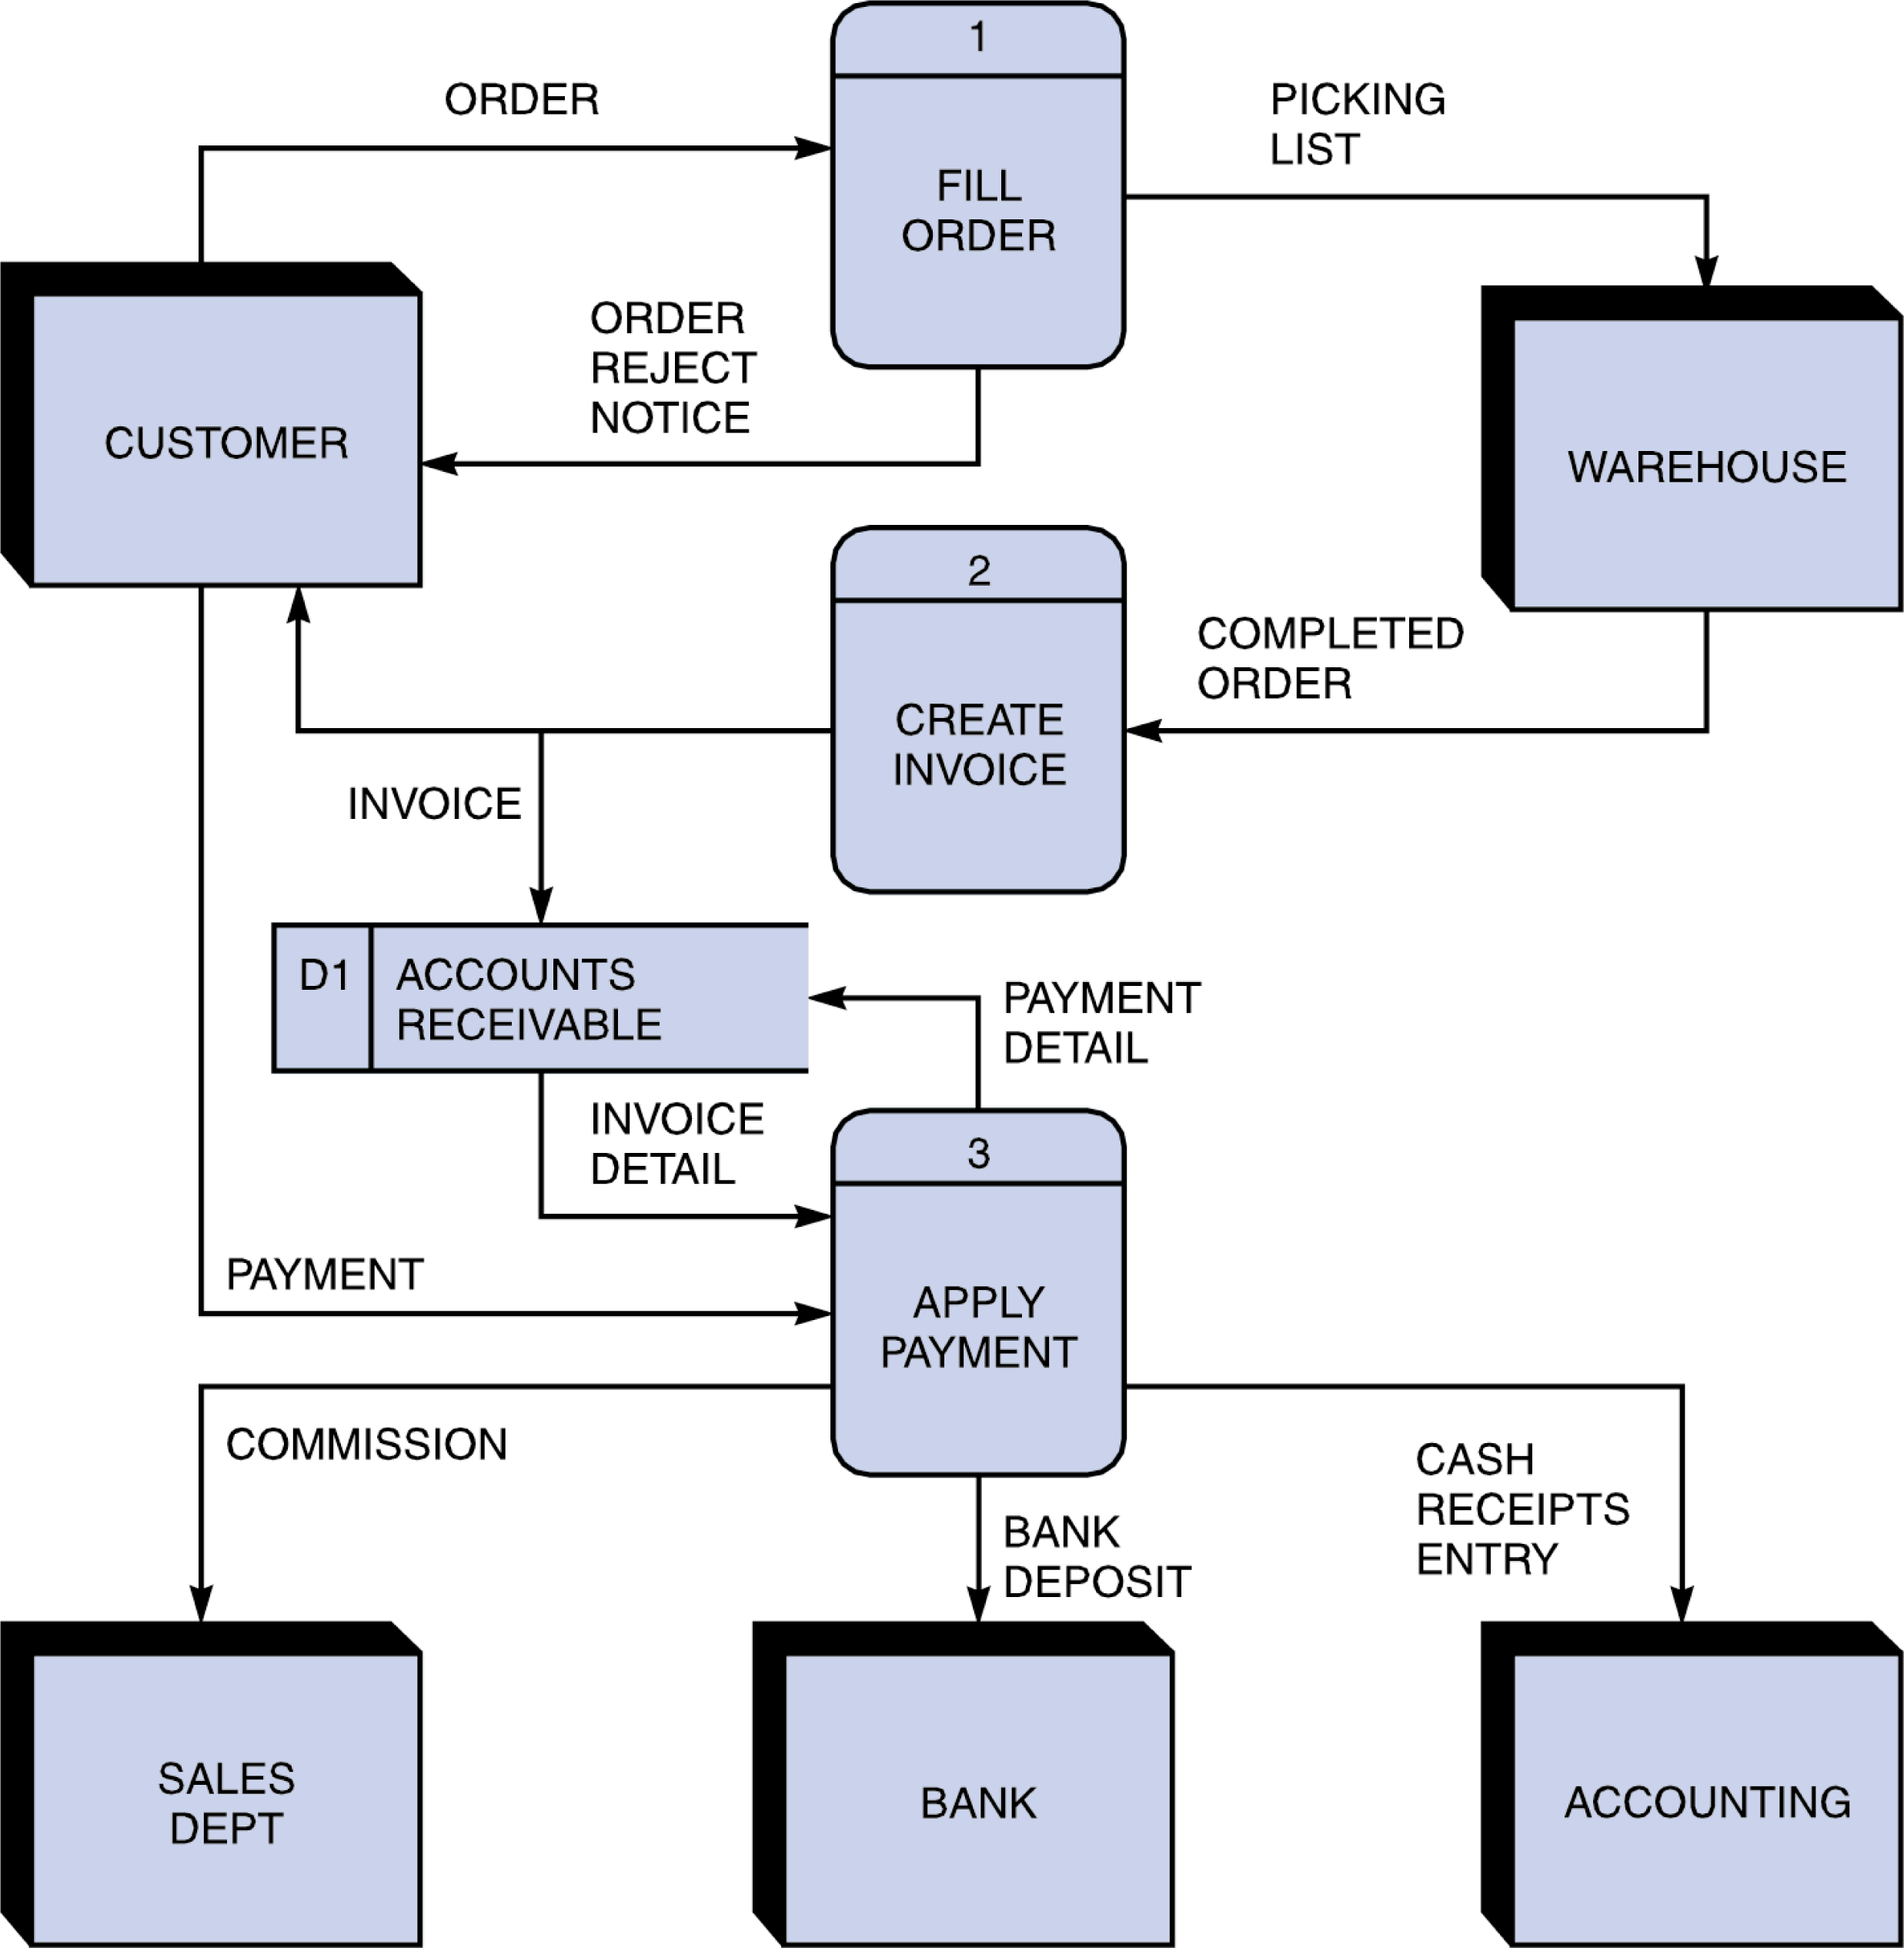Figure 1
   * Usually your start and end points (or program exit points) are denoted with a circle
   * D1 is an external data file (arrows point to whether it is input or output)
   * Arrows are labeled with the (general) input and output types…list major data structures or results like input of “Unsorted List and output labeled as “List Sorted by ID”
   * Not listed on the diagram above, but necessary for this project, you should list the major classes, functions and member functions in each block (under the name of the block)
4. Input RequirementsA detailed **list of all external inputs** (from files or keyboard) including a description of the **data type** and **range of valid values** for each input. For input file format and interactive user input, you need to write what data type is used for every field and valid value and length.
5. Output RequirementsA detailed **list or description of all outputs (**to files) including a description of the **data type** and **range of valid values** for each output.
6. Problem Solution Discussion  
   A summary description of the solution steps with algorithms analysis (1 paragraph, approximately 100 words). If any unusual techniques or algorithms are used that need further explanation, and additional paragraph may be used.
7. Data StructuresA description of choice of your data structures and justification. Of course the main data structure for the database is Binary Search tree. But for some internal operations you may have to use a few sub containers. So include a brief explanation for your choice. For example, "I have considered DS1, DS2, and DS3. Their pros and cons are summarized as follow... I choose DS1 over DS2 and DS3 because ...."
8. User Interface SchemeUser interface scheme should show the menu items at top level and items in sub menus and how to navigate through menus.
9. Status of Application  
   Note what IDE you developed the Final Project, and whether it compiled and operated properly on the csegrid. Note any requirements that were not met (per the project description). Note any known bugs or issues. If you did extra credit, note the status and what kinds of reports you provided.